Rusheel Shah, Elle Zadina

May 10, 2017

EECS 397: Final Project Report

**Project Topic:**

Virtual Reality/Augmented Reality using Lampi through Microsoft HoloLens

**Project Description:**

The aim of this project was to connect the raspberry pi in our lamp to a Microsoft HoloLens so that we can control the light on the physical lamp by moving virtual sliders shown through the HoloLen interface.

**Architecture:**

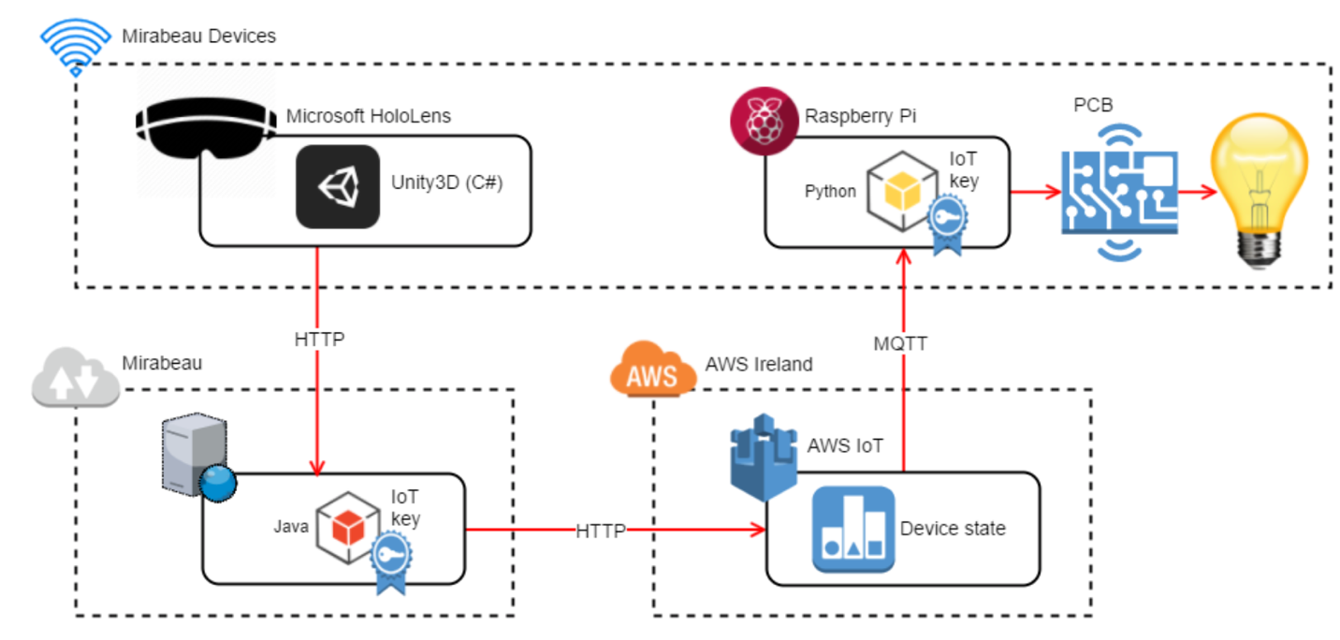

Our design follows Mirabeau’s design for hooking up a Microsoft HoloLens to a physical light switch. There are two distinct differences between our application and Mirabeau’s. First, they use Amazon’s AWS IoT platform to complete the MQTT communication while we use our own custom EC2 instance. Second, they use a generic Java app to complete the HTTP communication between HoloLens and server while we decided to use the NodeJS express application to complete HTTP requests

**Development**

Prior to beginning the development and implementation phase, we already had the Raspberry PI connected to our own spun up EC2 instance through MQTT. We decided to keep this current architecture. We divided the development phase into three distinct phases. In Phase I, Elle developed the UI for the Hololens in Unity. This includes the three virtual sliders, the color gradient, and the dynamic change of saturation color based on the current hue value. This phase also included saving the lamp state based on the current hue, saturation, and brightness sliders and storing the saved values in a JSON that is ultimately passed to the lamp. In Phase II, Rusheel developed the NodeJS express application with the intent to communicate with both the HoloLens and the EC2 instance. In Phase III, the final phase, both team members hooked up the HoloLens to the express application and the express application to the EC2 instance.

**Hurdles**

During this project, we came across a few hurdles and bugs. One of the main hurdles that we had to deal with for most of the development process was the exisiting mosquito protocol that was acting as the broker between the EC2 instance and the lamp. There was some confusion with the ansibled files from the previous project. It took us a significant amount of time to fix the mqtt-daemon along with testing it and making sure we were at a working state. Another hurdle was getting the created JSON from the HoloLens to be in the proper format to be passed along to the pi. As a result of these hurdles, we were not able to complete all the functionalities we proposed in the project proposal. Finding a fix to these hurdles took far more time than anticipated.

**Project Outcomes**

We were able to successfully create a virtual environment that can control a physical device. More than just the physical result. Both group members learned a great amount about the full development process using connected devices, especially the architecture and design phase.